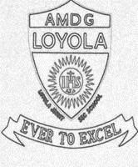
LOYOLA JESUIT SECONDARY SCHOOL
2026 JUNIOR CERTIFICATE MOCK EXAMINATION

PROVISIONAL MARKING SCHEME
PHYSICS
(100 marks)
SECTION A (20 marks)
- B
- D
- C
- C
- B
- B
- D
- C
- A
- D
- C
- D
- A
- C
- A
- A
- B
- B
- A
- C

SECTION B (50 marks)
- a. A test charge or a unit positive charge is a positively charged body with a charge of 1 coulomb. (1 mark)

b. Correct direction of force on charge T /1
Correct direction of electric field on charge T /1
Correct direction of force on charge U /1
Correct direction of electric field on charge U /1
(4 marks)

c. Like charges repel /1 unlike charges attract /1 (2mark)

- a. The phrase means light travels in a straight line. (1 mark)

b. $\frac{IM}{OB}=\frac{V}{U}$
$IM=\frac{0.2×10}{30}=0.067 m or 6.7 cm$ (3 marks)

- a. i. Don’t smell chemicals
ii. Label the chemicals
iii. Dispose expired chemicals. (3 marks)

b. Go and assemble at the fire assembly point.
Inform the teacher or lab assistant. (1 mark for any)

- a. Watt (W). (1 mark)

b. Both ionize the gas through which they travel
Both Cause fluorescence on certain materials
Both affect photographic plates (2 marks)
c. (i) 238
(ii) 92

- a. Anomalous expansion is the unusual expansion of water between 0 ºC to 4 ºC. (1 mark)

- $Efficiency=\frac{MA}{VR}×100\%$
$$E=\frac{3}{4}×100\%$$

E = 75$\%$
(3 marks)

- $Density=9.0×1000=9000\frac{kg}{m^{3}}$ (3 marks)

- a..(i) Solids (1)
(ii) Gases (1)
b. The sweet gain K E in the mouth /1, particles start vibrating /1 and increase distance between them /1. (3 marks)

c. W = mgh
$W=0.2×10×0.4$
W = 0.8 J (3 marks)

- a. Specific heat capacity is the quantity of heat energy required to change the temperature of the substance by 1 K. (1 mark)

b. $Q=mc∆T$
$Q=2.5×900×\left(40-20\right)$
$Q=45000 J$ (3 marks)

c. i. Writing on paper, chalkboard uses friction
ii. Brakes in a car use pads that offer a lot of friction
iii. Conveyor belts do not slip because (3 marks)

- a. i. A is incident ray (1 mark)
B is reflected ray (1 mark)
ii.45◦ (1 mark)

b The size of image is equal to size of object
The image is erect
The image is virtual
The image is laterally inverted
U is equal to V any two (2 marks)

SECTION C (30 marks)
- a.

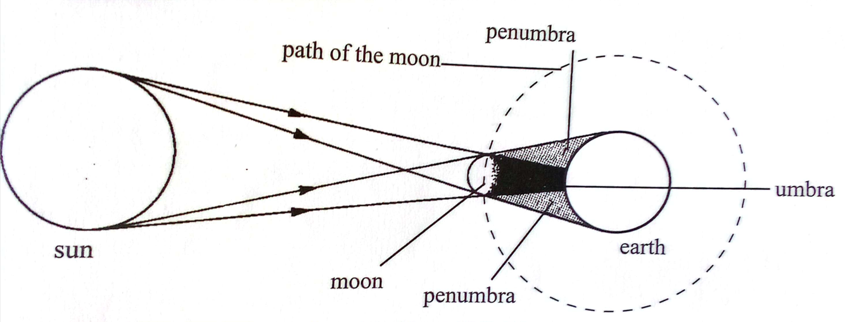

Correct diagram /1 any two correct labels /1 (2 marks)

When the moon, revolving around the earth, comes in between the sun and the earth./1
The shadow of the moon is formed on the earth./1
Depending on the position of the moon, some parts of the earth lie in the region of umbra /1 and some in the region of penumbra./1 (6 marks)

b. When length of a wire increases, /1 the collisions between electrons and metal ions /1 also increases, /1 hence increasing resistance. /1 (4 marks)

- a.
If a positively charged cloud is above the building, /1 a negative charge will be induced on the pointed edges of the arrestor, /1 electrons concentrate on these points and by the discharge action, negative ions are sprayed into the air and are attracted by the positive charges on the cloud /1. Thus reducing the charge on the cloud. When lightning strikes, huge electrical charge is conducted through the metal rod to the earth /1.
(4 marks)
b. (i). Gammar rays are used to detect leakages in underground water pipes. /2
(ii). Carbon 14 is used in carbon dating to trace the dates when some artifacts existed. /2
(iii). Radioactive materials can be used as tracers in medicine, eg tracing blood clots. /2

(6 marks)
- a.
Direct a narrow beam of white light from a narrow slit, in a semi-dark room, to an equilateral glass prism./1
Adjust the angle of incidence until a distinct band of colours is obtained on a white screen. /1
It is observed that white light is split up into a series of colours as it enters the glass prism /1. Different colours are deviated to different angles /1.
This splitting is called dispersion of white light. The colours are, red, orange,yellow, green, blue, indigo and violet. /1 (5 marks)

b. Connect a circuit with source of current, straight wire through a card board, a variable resistor and a switch. /1
Sprinkle iron filings on the card. /1
Close the switch. /1
Tap gently as you vary current using a variable resistor. /1
Iron filings settle in concentric circles around the wire, this shows magnetic pattern. /1

END OF PROVISIONAL MARKING KEY

